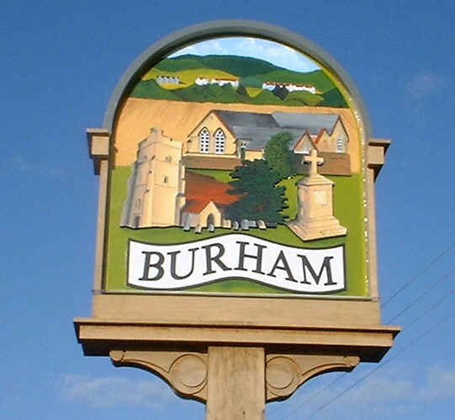
Burham Parish Council News
March 2021

Website: www.burhampc.kentparishes.gov.uk
Facebook page “Burham Parish Council”
All Parish Council information is included on these two platforms.

Virtual monthly meetings continue with a reduced agenda. Any items not included with these virtual meetings will not be forgotten, just on hold for the time being. Legally we are able to use virtual meetings currently up until May 2021 but it is hoped that face to face meeting can resume before then, when guidance changes.

Whilst the Covid 19 situation continues and we are forced to have Parish Council meetings virtually, as a reminder residents can still join in the meeting. An e-mail address would have to be provided. Any resident wishing to join in should contact me by noon on the Friday before any such meeting to have any questions/queries addressed to council members.

Burham United Charities are always available to the residents of Burham to cover the transport costs for any type of medical appointments including the Covid 19 vaccination. If you need any assistance, please contact Dave Young 01634 867669 or Roger Kiralfy 01634 869900.

With many residents still working from home, due to the Covid-19 situation, please be reminded that if you are using the free of charge parking facilities provided by the Parish Council, then the permitted vehicles MUST be taxed, MOT’d and insured and in a road worthy condition. SORN vehicles together with mobile homes/camper vans type vehicles are NOT permitted. The car parks are Bell Lane, Church Street, Village Hall and Village Hall overflow. Vehicles are checked on an ad-hoc basis.

A couple of planning updates which you may be interested in: TM/19/02199/OAEA: Trenport Southern Extension PV: Outline application: Development of the site to include ground remodeling, provision of residential dwellings, associated landscaping, drainage and highway works and creation of a riverside walk. The officer dealing with this application has advised the developer, Trenport to withdraw this application because there are too many amendments. There is no reply at the time this write-up was submitted.

TM/20/02988/OA: Land Northwest of Bell Lane Burham Rochester Kent. Trenport: Outline application. Residential development of up to 58 dwellings, playing pitch, car park and associated landscaping with access from Bell Lane together with access from Church Street: Land northwest of Bell Lane Burham. Observations submitted, which can be viewed on the TMBC website, under the planning section.

As residents are generating more cardboard and/or paper with increased home deliveries, please could we request that any large cardboard boxes are broken/cut up completely into smaller pieces as possible before trying to insert into the recycling bank, rather than just being folded. The exchanges on the container are increasing but with the actual weight being collected decreasing.

The lease on Court Meadow, the walking area between Court Rd and New Court Rd expires April 2021. We have been in contact with the land owners (Trenport) and await further details from them.

A local resident has been granted permission to attempt to seed wild flowers in the 1st smaller section of Court Meadow, corner of Rochester Rd/New Court Road. If successful, the same type of seeds could be used on the field behind the Village Hall (dog walking field).

We would like to welcome our new PCSO, Samir Patangwa who is now covering the Village. So if you see Samir around, I’m sure he would welcome a quick “hi”. PCSO Joanne Tiller, our previous PCSO, has moved to a specialist role.

If you have any items that you would like the Parish Council to discuss, just give me a call on 01634 685936, e-mail me on pam@burhampc.co.uk or join in at the next scheduled meeting, which is due 29 March 2021 - Virtual. Pam Saunders – Clerk.

