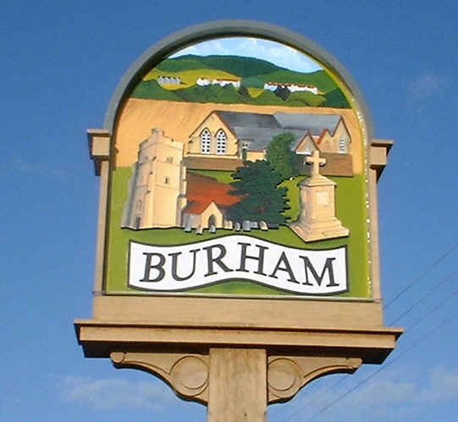
Burham Parish Council News
December 2020/January 2021

Website: www.burhampc.kentparishes.gov.uk
Facebook page “Burham Parish Council”
All Parish Council information is included on these.

Another year has nearly passed and what a strange 2020 it’s been.

Virtual monthly meetings continue with a reduced agenda. Any items not included with these virtual meetings will not be forgotten, just on hold for the time being. Legally we are able to use virtual meetings currently up until May 2021 but it is hoped that face to face meeting can resume before then, when guidance changes.

Whilst the Covid 19 situation continues and we are forced to have Parish Council meetings virtually, as a reminder residents can still join in the meeting. An e-mail address would have to be provided. Any resident wishing to join in should contact me by noon on the Friday before any such meeting to have any questions/queries addressed to council members.

Parking in parish owned car parks which include Bell Lane, Church Street, Village hall and Village Hall overflow: As a reminder all vehicles using these free of charge facilities must be taxed, MOT’d and insured and in a road worthy condition (All of these conditions apply not just some). SORN vehicles are not permitted nor are camper vans/mobile homes. Sleeping/living in vehicles parked in these areas is also not permitted. Random vehicle checks are carried out and if a certain vehicle is found not to comply with the rules, a letter is placed on the vehicle requesting removal. (We have no facilities to trace the owners/registered keepers). If the vehicle is not removed, then the Police are contacted and a letter passed to the Police to pass on to the owner requesting removal,

Whilst I have chased TMBC in relation to the litter picking along the Pilgrims Way (Split road), their response was - mid October - “Sorry I have raised the issue however we still do not have the resources to carry out the work”. I even requested that if we could provide the man power/labour would they be prepared to close the road and was advised “Sorry but this would not be possible. The cost of a total road closure would be very high”. I will continue to chase on a regular basis.

I have also made enquiries again in relation to the Saturday bulky refuse collection via TMBC contractors. No date available when this service will resume.

TMBC Parking Action Plan phase 12 (Informal Consultation): Proposed double yellow lines in Bell Lane to stop obstructive parking opposite the disabled bays near surgery, this is a safety priority.

New Court Rd footway/cycleway (breaking up from Church Street to Bell Lane): This was reported to KCC Highways (as the acting authority) back in July. We have been advised that “We (KCC) are currently pursuing revenue streams to fund the work and will update you once we know whether the work will be undertaken this financial year or if it will have to wait until post April 2021” We have now been advised that the work should be carried out on the 3 December for 2 nights from 1900 hrs until 0300 hrs. Highways are carrying out this work outside normal working hours to minimize the disruption to users given there is no alternative footway.

Remembrance Sunday 8th November: A social distance remembrance service took place at the war memorial at 2pm with the correct Covid 19 processes in place (no Church Service afterwards), which was well attended by over 25 residents.

Via social media, we have managed to secure 6 limited edition (run of 75) commemorative plates from an ex-Burham resident, who left the village 15 years ago. They feature Burham War Memorial, Vinnes Youth Club, Golden Eagle and Church Street, Village Hall, The Old Church and the Church in Church Street. In due course, they will be hung in the Parish Building for residents to view (once the building has re-opened to visitors). We would like to thank Mr. Trevor Rudge, the original owner.

Over the last eight months or so with the Covid 19 situation changing rapidly, things can change at very short notice, so just check with me if you need clarification regarding any parish council issues.

Burham Parish Council would like to wish all our residents a very happy, healthy Christmas and good wishes for 2021. Let’s all hope that 2021 brings better news than 2020!! Stay Safe!

If you have any items that you would like the Parish Council to discuss, just give me a call on 01634 685936, e-mail me on pam@burhampc.co.uk or join in at the next scheduled meeting, which is due 21st December 2020 - Virtual. January 2021 meeting is scheduled for 25th – format of January’s meeting (either via MS Teams or normal face to face) to be agreed nearer the time. Pam Saunders – Clerk.

