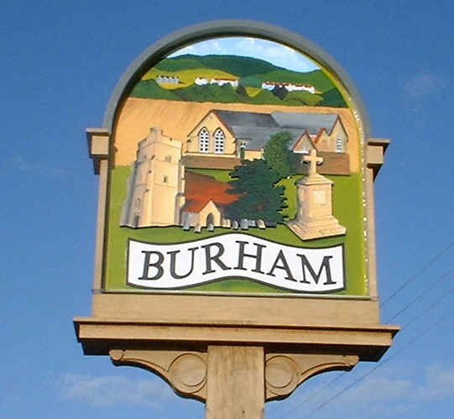
Burham Parish Council News
April 2021

Website: www.burhampc.kentparishes.gov.uk
Facebook page “Burham Parish Council”
All Parish Council information is included on these two platforms.

Virtual monthly meetings continue with a reduced agenda. Any items not included with these virtual meetings will not be forgotten, just on hold for the time being. Legally we are able to use virtual meetings currently up until 6th May 2021, although the relevant bodies are pushing for this date to be extended. If no extension is granted then face to face meetings can resume after that date. In light of this, under recommendations from National Association of Local Councils, we may combine the Annual Meeting of Electors and the Annual Meeting of Parish Council (Election of Officers) into one on the 26th April. The Annual Meeting of Electors is due on 26th April, but the Annual Meeting of Parish Council (Election of Officers) is not normally held until towards the end of May. Any combined meeting on 26th April would be virtual. A final decision will be made nearer the time.

Whilst the Covid 19 situation continues and we are forced to have Parish Council meetings virtually, as a reminder residents can still join in the meeting. An e-mail address would have to be provided. Any resident wishing to join in should contact me by noon on the Friday before any such meeting to have any questions/queries addressed to council members.

The lease on Court Meadow, the walking area between Court Rd and New Court Rd expires April 2021. Trenport have advised that in principle they are happy to extend the lease for another two years under peppercorn rent. So we await further details. We are obtaining quotes for a 3rd pedestrian gate into Court Meadow, where the hedge has been breached near to the vehicle access.

We have noticed that increased litter in the village is occurring. Whilst we normally do have a village wide litter pick due to the restrictions imposed we are not able to until the restrictions are lifted. Please therefore take your litter home or use the bins provided.

Burham United Charities are always available to the residents of Burham to cover the transport costs for any type of medical appointments including the Covid 19 vaccination. If you need any assistance, please contact Dave Young 01634 867669 or Roger Kiralfy 01634 869900.

Burham Parish Council website will be changing soon. Further details to follow.

As a reminder, please be a responsible dog owner (we know that most of you are) and bagged up and dispose of correctly, any dog fouling. There still appears to be some that “forget”. Dog fouling bags are available in many areas of the village. Dog fouling is not only deeply unpleasant, it is dangerous. Whilst rare, contact with dog excrement can cause toxocariasis – a nasty infection that can lead to dizziness, nausea, asthma and even blindness or seizures and in rare cases death.

If you have any items that you would like the Parish Council to discuss, just give me a call on 01634 685936, e-mail me on pam@burhampc.co.uk or join in at the next scheduled meeting, which is due 26 April 2021 – Virtual “Annual Meeting of Electors” – see above for further information. Pam Saunders – Clerk.

